Karl Henize

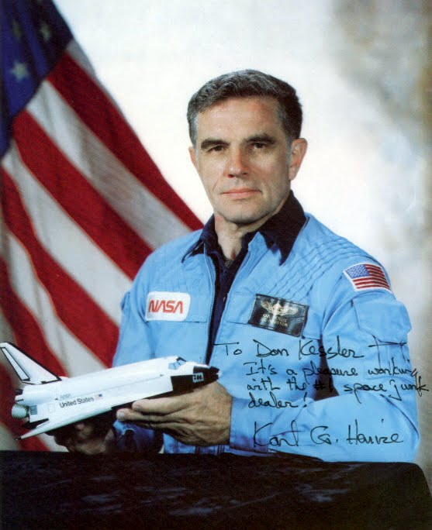

Karl G. Henize, 1926-1993 Astronaut, Scientist, Family Man, and Mountain Climber. Karl’s photographic survey plates of the southern sky, completed in 1951, are now located at the Pisgah Astronomical Research Institute where they have recently been digitally scanned for a more accurate and detailed analysis.

Karly was selected as a scientist-astronaut in 1967. After becoming the oldest astronaut to go into space in 1985, Karl joined the orbital debris team. As an astronomer, he was a key team member in obtaining and interpreting optical observations of orbital debris. Karl died attempting another life-long ambition....to climb Mount Everest. A Memorial Service was conducted for Karl on October 16, 1993 at JSC.