John Gabbard

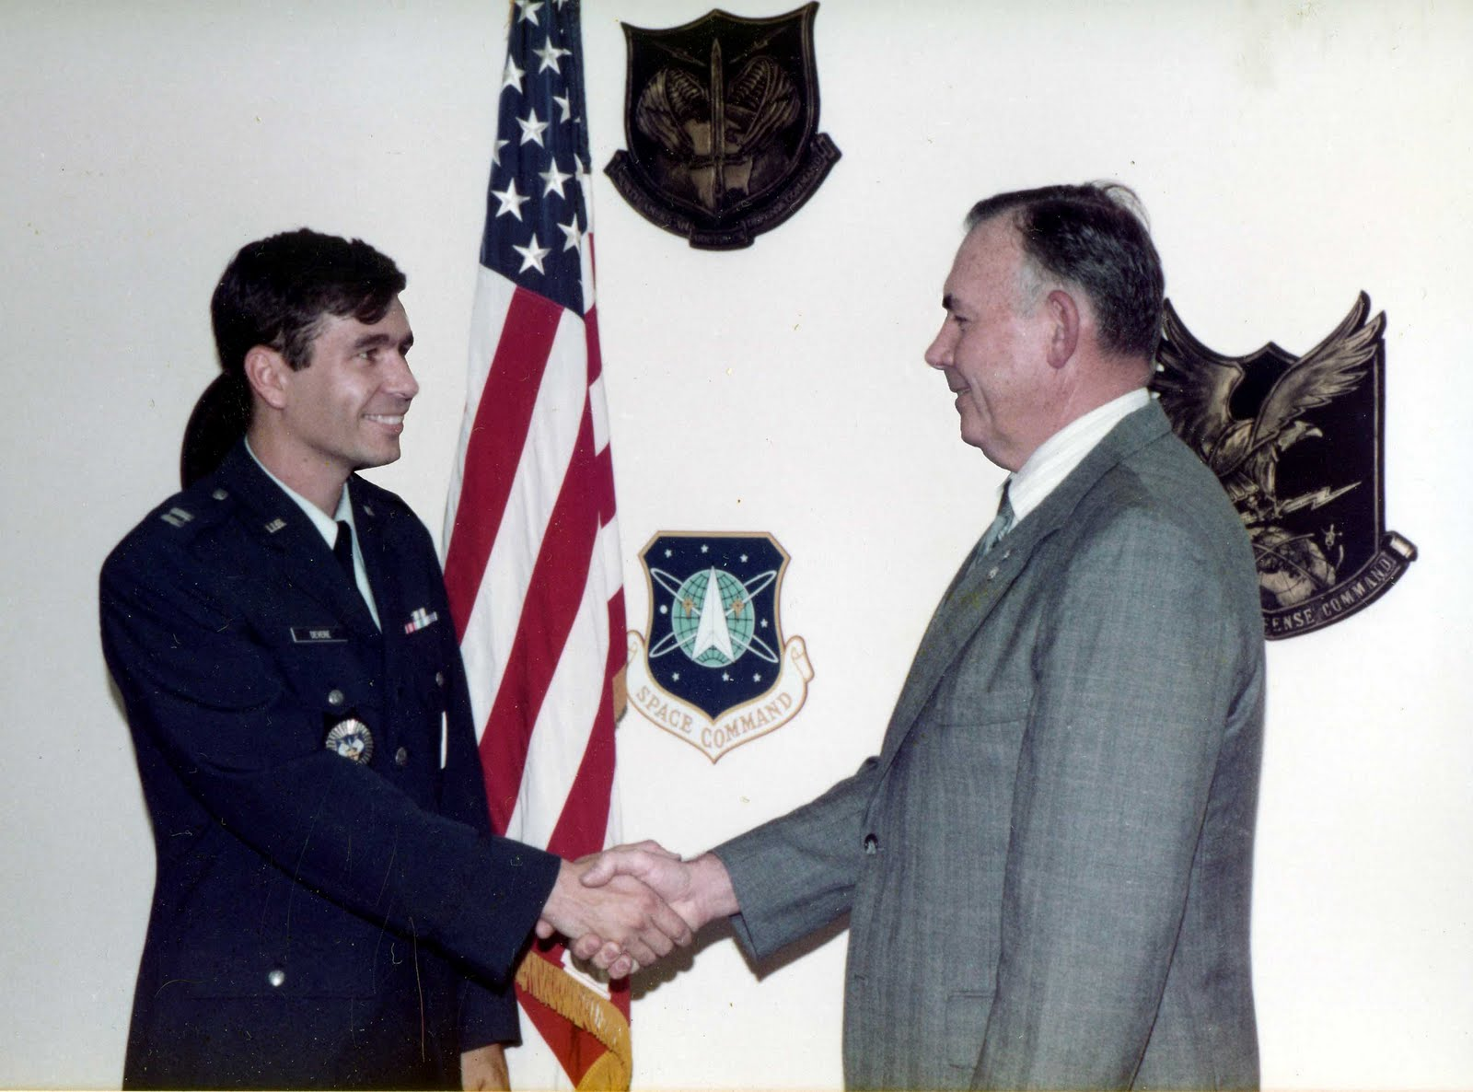

John Gabbard:1921-2003. John (on the right), a mentor to Taft DeVere (on the left), congratulates him on his 1982 promotion to Captain. John Gabbard was one of the early pioneers, retiring from AF Space Command in 1982. He will be remembered by many for his Gabbard Plot; however, John contributed much more. NORAD had the charter to catalog all man-made objects, but there was no charter to keep track of events that produced debris. When any object produced unexpected debris, it was classified as an object associated with the launch of the payload. John saw a need to maintain a record of these events. In 1971, John presented the paper "Satellite Break-Ups" at a AAS/AIAA Conference, identifying 24 satellite explosions and used his plot to illustrate the characteristics of those explosions. Although NORAD did not expand its charter to include keeping track of these events, John continued to maintain a record. NASA later contracted Teledyne Brown Engineering, where Nick Johnson and John established the catalog of fragmentation events currently maintained at JSC.