Burt Cour-Palais

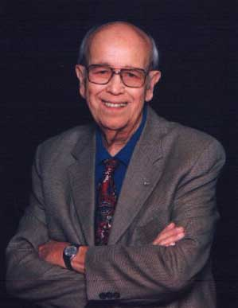

Burt Cour-Palais, 1925-2004 The "Grandfather" of Orbital Debris Burt lay the foundation for both Herb Zook's and Don Kessler's career. As head of the Meteoroid Science Branch prior to 1970, Burt introduced his team to the world of meteoroids and what happens when they impact surfaces at hyper-velocities. After helping establish the orbital debris office in 1979, Burt joined it and continued his own research in developing and testing shielding for spacecraft. After retiring from NASA in 1989, Burt continued his work through Southwest Research. More details concerning Burt's career are at <http://meteor.uwo.ca/kessler/Burt%20Cour_Palais.pdf>